People First!

INSIDE THIS ISSUE: | Inaugural Issue
The Motto: People First  1  Just Think About It 2 |  | What is “People First!”?

People First  My Credo  for Decades | "People First" has been a personal slogan since before the turn of the century. This phrase embodies my feelings that business, trade, institutional knowledge, world improvements only happen when People can interact positively with other People.  My name is Bill Gutches and I have had wonderful experiences to date in my life and my profession. My hope is that I can share these experiences with others in a beneficial way. | Recently I have been learning about new technology topics coming up in literature:  - Big Data,  - Internet of Things (IoT),  - SEO,  - Social Media,  - AI (ChatGPT)…  I find it fascinating how our behaviors are changing now that we can reach specific individuals through Text and Images instead of a phone call, email, or a letter! | The changes that we can expect to experience in the coming 5 to 15 years should be absolutely amazing AND we each need to be prepared to understand how to use these changes to our best advantage.  Part of this evolution includes the use of on-line social networking services like LinkedIn. This service is becoming a Career Portal for all who choose to use it. Let me and my experiences help you navigate and take full advantage of this capability.

Just Think About It: | 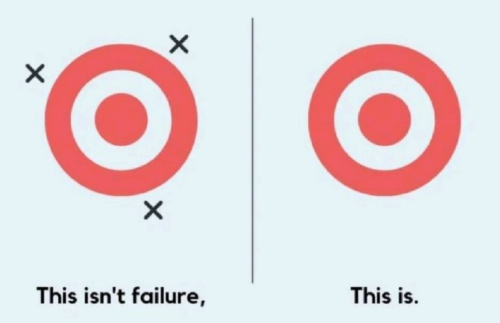 | You can’t win if you don’t try.  Buy a lottery ticket or you can never win the pot.  Win or Lose: LEARN!  Knocked down seven times. Get UP for the Eighth time.

William H Gutches, LLC dba  The Path To Inkc | 484-925-1535  bgutches@thepathtoinkc.com
531 Elliott Drive | Facebook: @thepathtoinkc.com
King of Prussia, PA | Twitter: @bgtpti
19406
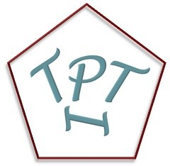 | If you are willing to take the time, let's have an initial discussion (for now 30 to 40 min on ZOOM) to talk about your personal plans and goals. My hope is that we will focus on how YOU would like to earn income with a company of your own, contract work or employment, investments and other passive income, and product / service sales. Lets make a plan together.

Potentially Useful Links:

The Path To Inkc Web Site | www.thepathtoinkc.com
The TPTI Mission | https://thepathtoinkc.com/blog/

